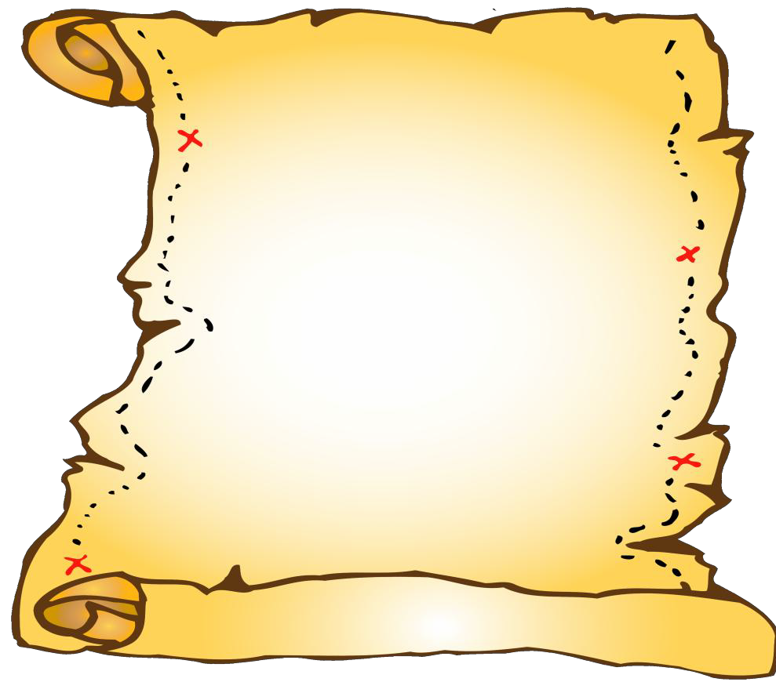


--
www.mcornelsen.yolasite.com & www.usd210.org

Dec. 21st, 2012
Mrs. Cornelsen
mcornelsen@usd210.org
ECDC-507 S. Madison
Office: 620-544-4334
Fax: 620-544-4335

Cornelsen’s Buccaneer Times


Animated Literacy: Baby Barnaby
This week we learned about Baby Barnaby. Barnaby was a bouncing baby boy who liked to play beautiful tunes on his banjo. He was even asked to play in the Boston Marching Band. One day Barnaby bumped into a bumblebee and broke his banjo. He put the pieces of his banjo back together and made and even more beautiful banjo and painted it blue. We practiced listening for “b” at the beginning and ending of words. After Christmas: Gilda Goose – Sound of “g” and Crazy Camel – Sound of “c”.
Writing: How do you spell that?
Some of the letters that we have worked on have different ways to spell their sound. We are discussing these with the children so they will know other options when sounding out words. For example: u (a), o (au,aw), m (mb), x (ks), s (c), r (wr), j (g), k (c,ck), f (ph). After Christmas: writing the letter “Gg” and “Cc”.
Gingerbread Fun!!!
On Wednesday this week the children got the opportunity to rotate around all 5 kindergarten classrooms and partake in different gingerbread activities. They made a gingerbread man glyph, found the area & perimeter of a gingerbread man, retold the story of the gingerbread man story, played gingerbread bingo, and had a number scavenger hunt. It was a lot of fun!
Reading: Little Readers
Our new little book for next week is “Fly Away”. We will be practicing reading this sight word book for another week. The words that we will be practicing are “will” and “fly”. Please have your child read this to you when they bring it home next week.
DRAW TO READ AND WRITE: We learned how to draw a “bus” this week. Practice making 3-4 letter words using these letters: p, u, o, m, x, a, d, t, s, r, h, ar, j, k, f, b: pup, pop, mom, ox, ax, dad, top, stop, rat, hat, star, jar, mask, fox, bus.

Sat., Dec. 22nd – Wed., Jan. 2nd – Christmas Break
Thurs., Jan. 3rd – School Resumes
Tues., Jan. 29th – Kansas’ Birthday
Birthdays: January- Giovanni, Jake and Yasmin

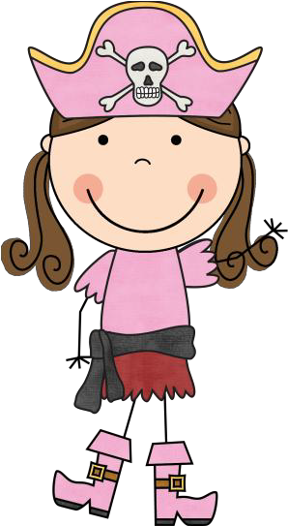
Important Message!!!

1. Visitation of Classroom: Parents are welcome to visit their student’s classroom, but are to contact the teacher for the best time at least one day prior to visit. Generally, the first period of the day is not the best time to visit.
2.Procedure for visiting the Building: Due to the safety of our students, each person is to enter the building at the central entrance near the office. Visitors are to check in with the office and state their business with the school. Exceptions are parent-teacher conferences and programs where invitations have been extended.

DANGER! Do Not Forget!!
- Bring water bottles to school.
- Dress appropriately for the weather.
- Bring Box Tops.
- Read and fill out Book-It form.

Weekly Words
New Words: will, fly
11 Color Words & 11 Number Words
Sight Words: I, see, ride, on, play, with, my, can, little, big, look,
for, find, the, you, and, like, to, me, too, we, get, they, go, run, said

